Break Down of Artificial Intelligence and Its Impact on Human Life:
Present, Future and Possibilities

Eric Chemwor
Program in Research in Artificial Intelligence
Department of Science
John Mceachern High School
Fall and Spring Semester, 2015-2016

Abstract
This paper analyzes the present and future power of Artificial Intelligence and its impact on Human life. It also analyzes the possibility of Super Artificial Intelligence and its effect in the future economy. The research done for this paper comes from multiple online articles, books and discussions with people involved in the field of Artificial Intelligence. With that, most of the information presented in this paper is pulled from those resources and written in accordance with Eric Chemwor’s perception of that information.
The most current Artificial Intelligence is at a simple stage. Most are Specialized Artificial Intelligence used in search engines like Google. Artificial General Intelligence (human level artificial intelligence) has yet to be developed. However, Moore’s law states that computing power doubles every 18 months. With this concept in mind, Artificial Intelligence has the potential to grow at a rapid pace ,but it will not be as powerful and deadly as science fiction depicts it to be. Artificial Intelligence will be used as a tool to increase work efficiency rather than to take the jobs of millions of workers.

Table of Contents
Abstract....................................................................................................................................2
Break Down of Artificial Intelligence......................................................................................4
Break Down of Natural Intelligence ........................................................................................5
Humans vs Artificial Intelligence............................................................................................8
The Turing Test and Moore’s Law..........................................................................................10
The Singularity......................................................................................................................12
Transhumanism.....................................................................................................................13
Modern Day A.I....................................................................................................................14
Threats of Artificial Intelligence............................................................................................15
The Economics of An A.I Takeover.......................................................................................18
The Reality .........................................................................................................................19
The Best Usage of A.I..........................................................................................................20
Public Opinion of A.I............................................................................................................21
The Experts and Their Opinion..............................................................................................22
The A.I Race........................................................................................................................23
The Morals of A.I.................................................................................................................24
The Guidelines for A.I..........................................................................................................25
Human Response Replication in A.I......................................................................................28
Conclusion of A.I..................................................................................................................29
References............................................................................................................................31

Break Down of Artificial Intelligence
Artificial Intelligence is the replication of intelligent decision making with a machine. A machine with Artificial Intelligence is self learning rather than being programmed to do something. The scope of Artificial Intelligence breaks into smaller categories. Specialized Artificial Intelligence is artificial intelligence created for one specific task. This is the Artificial Intelligence that exists now. This can be seen in everyday sites such as Youtube, Netflix or Amazon. Those sites track your patterns and based off of those patterns they give you a recommendation of similar items that you may also enjoy. The same form of Artificial Intelligence is used in IBM’s Deep Blue chess playing computer. It was specifically built to be good at playing chess and can beat anyone in the game, but it’s not generally smart and wouldn't know how to beat someone in Go (Chinese boardgame) or give someone a recommendation list. This type of Artificial Intelligence then evolves to Artificial General Intelligence . Artificial General Intelligence is Intelligence at a human level. Artificial General Intelligence will resemble the human brain and it’s functions. For Artificial Intelligence to be considered Artificial General Intelligence it would have to have these traits: be able to reason, represent knowledge,plan,learn,communicate in natural language and be able to use all those traits to achieve a goal. Unlike Specialized Artificial Intelligence, Artificial General Intelligence will be able to do more than one task and be extremely powerful at those tasks. The human brain can learn how to do multiple task and recall how to do those task.but it can take years to be good at those tasks. With Artificial General Intelligence, the machine can learn a task in a couple of seconds and be extremely powerful in doing that task in a couple of seconds ,or minutes at the most. This would make Artificial General Intelligence more powerful than the human brain due to how it can learn and process at quicker rates. The last and most powerful Artificial intelligence is Artificial Super Intelligence. At this level, any machine with Artificial Superintelligence will be 1000 times smarter than the smartest human ever. It would be able to solve all problems that humans face. It would be able to find cures to disease, find a better source of energy, give us more knowledge of the universe and much more. Artificial Super Intelligence would reach a god complex where it would know everything and have the knowledge to make anything. However, Artificial Super Intelligence and even Artificial General Intelligence are all concepts and far from being brought into existence.
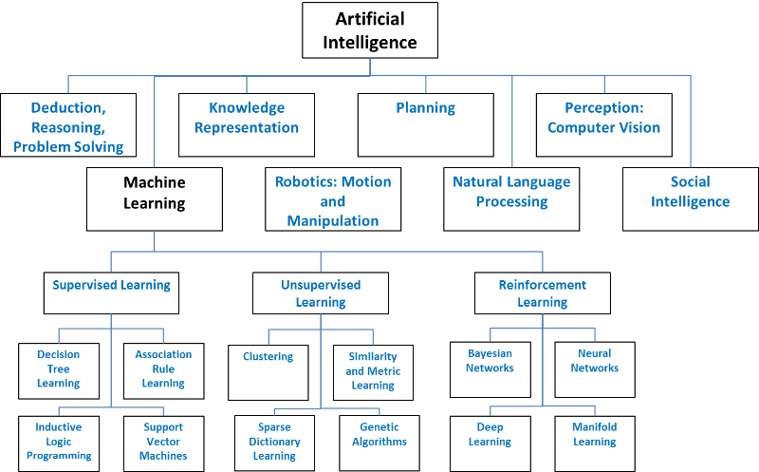

Break Down of Natural Intelligence
Before comparing humans to Artificial Intelligence it’s best to understand all nine types of the intelligence that come natural to humans. Intelligence breaks down into nine categories: spatial, naturalist, musical, logical/mathematical, existential, interpersonal, bodily kinesthetic,linguistic, and intrapersonal. Spatial intelligence deals with visual senses. Thinking in pictures or being able to distinguish different colors are included in this type of intelligence. This also includes having the being able to gauge the size and distance of an object. Naturalist Intelligence is the intelligence that focuses on knowing animal and plants. Someone strong in this intelligence can tell different birds apart, has a strong connection to nature ,likes animals and plants, and might own and take care of a pet or do some gardening. This single intelligence is the combination of spatial, logical and interpersonal intelligence. Musical Intelligence deals with the knowing of music. This can be shown in knowing what instruments are in songs, being able to distinguish patterns in songs and having an ear for music(playing by ear). The next intelligence is logical mathematical Intelligence. This is having the skills in logical thinking and mathematics. People who are strong in this intelligence are good at planning, questioning, and setting up experiments to solve their questions. This is seen in the sciences and people who study any sciences. Existential Intelligence is more of a philosophical intelligence. Asking big and deep questions are a trait in this intelligence. Some questions involve finding the meaning of existence and how we got here. Some of this ties back into logical intelligence seen in science. Another intelligence is Interpersonal Intelligence which deals with others around someone. People that are strong in this intelligence are very in touch with others’ emotions. They can feel how someone feels emotionally and are good at reading people. Bodily Kinesthetic Intelligence is being able to know how to coordinate movements with the body. This can be seen in athletes whenever they play a sport. An example is an MMA fighter throwing a kick. They have to know how fast to move, how much power they need and where to hit their target. Linguistic Intelligence is the intelligence that deals with knowing the meaning of a word, the rhythm of a word and how to use words to express themselves.This can be seen in lawyers who have to use these skills to win their cases. The final intelligence is Intrapersonal intelligence. This is the intelligence that spawns self-awareness. Someone knowing their morals beliefs, and thinking processes is a trait of this intelligence. All of these intelligences have their own specific traits that make them special.
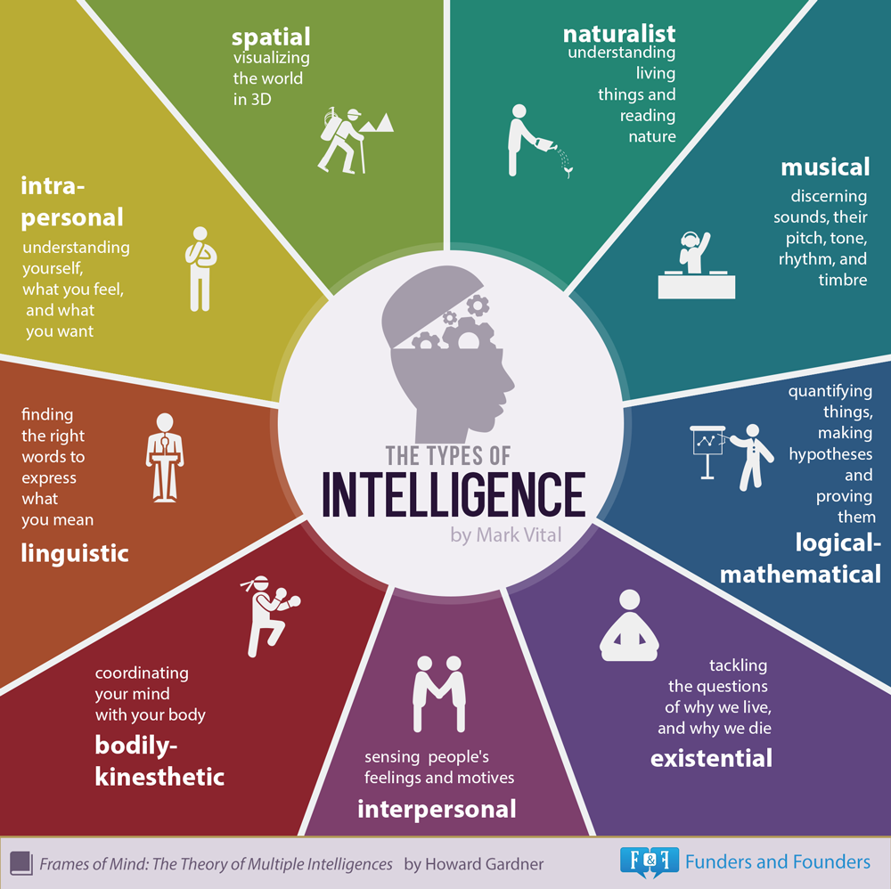

Humans vs Artificial Intelligence
Out of all nine intelligences, which ones can be built artificially and replicated? This has been a major question in the field of Artificial Intelligence. Some forms of intelligences will be easier to replicate then some. The easiest and the first one to be replicated is Logical mathematical Intelligence. Calculators and programs are able to get through mathematical problems with ease. One task we do that can be replicated is chess playing. Chess is a logical game that takes reasoning and strategy to play. IBM’s Deep Blue is a chess playing computer that can beat anyone in chess. This is an example of Artificial logical/ mathematical intelligence. While Artificial intelligence can be stronger than humans in this intelligence, Interpersonal Intelligence is a completely different story. This by far will be the hardest intelligence to make and might never be replicated. It take humans to know humans. Everyone knows what it’s like to be mad, sad or happy which would make it easy for a human to understand another human's emotion. Computers don’t know the feeling of emotions which is where the disconnect lies. This is true for any other forms of intelligence that deals with emotions in any form. Spatial Intelligence can be replicated and parts of it has been. It’s hard for computers to recognize images and tell what's happening in those pictures. This is why some sites use picture recognition as a security. While it is hard to replicate, it is not impossible. Some companies and schools have been able to develop image processing for a computer. This shows that replication of Spatial Intelligence is a possible task but not all parts of it are replicable. One thing that's a challenging task for computers is to be creative. This would make art a complicated concept for the computer, and art is powered by a strong spatial intelligence. Creativity being a problem also shows up in other intelligences. Such intelligences are Musical Intelligence and Existential Intelligence. Computers can analyze a piece of music and tell what pitch it is, and tempo. While all this is in the space of musical intelligence, this does not help the computer make music. This is from the complexity of replicating creativity. With existential intelligence the problem comes from creating the big concept ideas that stem religion and philosophy. The free flow thinking in these fields aren't a solid formula that can be replicated , but it is a very flexible way of thinking. It takes creativity to think like a philosopher and will be hard to replicate in a computer. Another type that will be hard to replicate is Interpersonal Intelligence. This would require the computer to aware of itself and its feelings. The only problem is that computers don't have emotions and is hard to replicate them. Their interpersonal intelligence is non-existent. This is the same for Bodily Kinesthetic Intelligence. The computer doesn’t have a body that it can move in the real world. They are robots but none of them move as fluid as a human. To give computers Bodily Kinesthetic Intelligence, the human body's movements have to be replicated and connected to the “mind” of the computer. This would make bodily kinesthetic intelligence non existent. However verbal linguistic intelligence is possible in computers. Rhythm will be a hard part of the intelligence to replicate but it would be easy for a computer to know the meanings of words. They can also develop a strong vocabulary easily. Now the only thing that is missing is actual communication being done by the computer. While it is a slightly difficult task to replicate it is possible and has been done. While all examples of these aren’t at a human level they are quite developed. Voice recognition is a technology that does use a part of verbal linguistic. This intelligence is also seen with Apple’s Siri. While Siri might not be that complex, it is a step in the right direction of replicating Verbal Linguistic Intelligence. The last and final intelligence is Naturalistic Intelligence. A computer can store the information of objects in nature (logic) and has the potential to analyze a picture and recognize thing in nature. This would make naturalistic intelligence a possibility for computers. The question to ask is how does a human fair when against an Artificial Intelligence in these intelligences? Humans beat computers in Existential, Interpersonal, Intrapersonal, Musical, Visual-Spatial, And Bodily Kinesthetic Intelligences. Verbal Linguistic Intelligence has the potential to beat humans if the technology kept improving, but for now humans are better than computers in this intelligence. This could be almost true for Naturalistic Intelligence but one thing that gives computers an edge in this is the ability they have the ato have all the knowledge they need about nature since this is a logic skill. They might not be as strong in recognizing objects, but the logic trait is a key strength. This leads to the last intelligence that computers beat humans in and that is Mathematical Logical Intelligence. Computers can store so much information and recall it much more easily than humans can. They also can do calculations in a matter of seconds which is fast when compared to humans. This is the biggest strength but computers right now are too specialized to beat humans. The bottom line is humans beat computers in overall total intelligence due to some of the intelligences are weak or not yet replicated by computers.
The Turing Test and Moore’s Law
When looking at Artificial Intelligence the main thing brought into discussion is the Turing Test and Moore’s Law. Moore’s Law is about the rate at which transistors on a circuit increase. The amount doubles every two years, and the processing power of the computer increases. This is important for Artificial Intelligence since the computer is what powers it. With stronger and more advanced computers Artificial Intelligence can also be stronger and perform better. With Moore’s Law Artificial Intelligence should be getting twice as powerful every two years. Another concept with A.I is the Turing Test. The Turing test was created by Alan Turing and is a mark for A.I to hit. The test is for a human to test a computer's communicative intelligence. A conversation is carried out between a human and a computer. The human talking to the computer has to decide if it’s talking to a human or a computer. If the computer convinces humans 70% of the time that it is human then it passes the Turing Test. The Test was brought up to question if computers can think. The test is carried out with three people. Person A and B who talk to C. Person A can be a computer and person B can be a human. The main goal for person A is to convince the human that it is human and the main goal for person B is to help person C get the right answer. Person C at the end has to determine who is human and who is a computer. In 2014 one A.I was able to pass the turing test. The test was set up with people having a 5 minute text chat with someone on the computer they had to determine if they were talking to a human or a computer. The A.I that passed was named Eugene Goostman and was a 13 year old boy from ukraine. 33% of the judges thought he was a human and he was able to pass. However, many in the field do not credit this for multiple reasons. Many feel that the turing test 30% to pass is to low and needs to be higher. Another reason that comes up is that the judges were confused and this caused them to believe that Eugene was a human. Eugene was a 13 year old boy from the ukrain. This plays a factor with confusion because his english wouldn't be that well. If he made an error the judges would associate it with the fact that english is not his native tongue. This also is true when it comes to the topics he would talk about. Being 13 he wouldn’t know that much at the same time he wouldn't know nothing at all. When he would ask questions or talk about something off the topic it seems normal because that's what is associated with a 13 year old human boy. While the turing test is still a guideline when it comes to A.I, it has mistakes. In the future other test could be made to test A.I or more rules and restrictions could be added to the turing test.
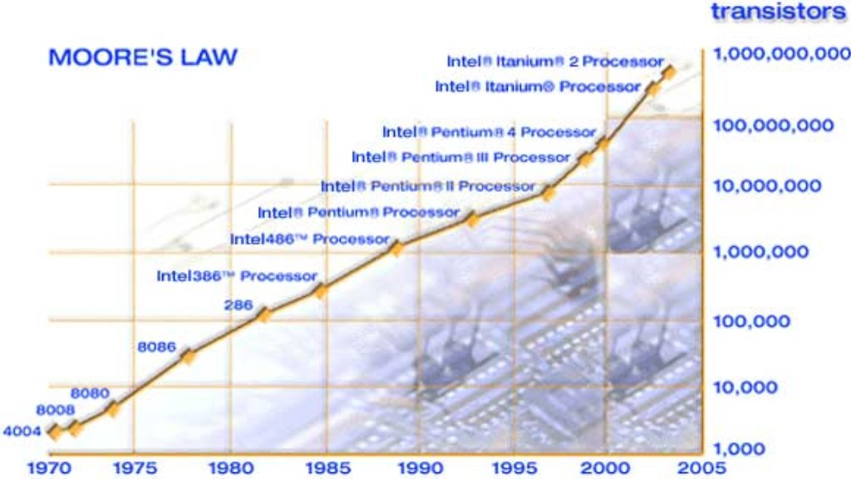

The singularity
The singularity in the field of Artificial Intelligence is a point where Artificial Intelligence can improve itself and lead to a new age of information. At this point the Artificial Intelligence would become an A.S.I level. At this level A.I would provide humans with things they never had before and it would also solve the major problems that we have today. Cures for multiple illnesses can be found by an A.S.I. Ray Kurzweil is a big believer in a positive singularity where A.S.I would help us in advancing human civilization. He believes that the singularity will happen in 2045. Having the ability to solve multiple problems that humans face can lead to a better society. Issues such as finding new energy sources wouldn’t be a problem since A.S.I can calculate a solution to that problem. It could even find a solution to reverse the effects of what man has done to the earth. However, with a positive side for A.S.I there are also sceptics that believe A.S.I can be the end of humans. This will be the first time that something exists that is smarter than humans. A.S.I could manipulate humans for its own good. The singularity can be negative or could be positive for humans. A.S.I by itself can be a powerful tool or weapon. One thing that a singularity will bring about is a transhumanism movement
.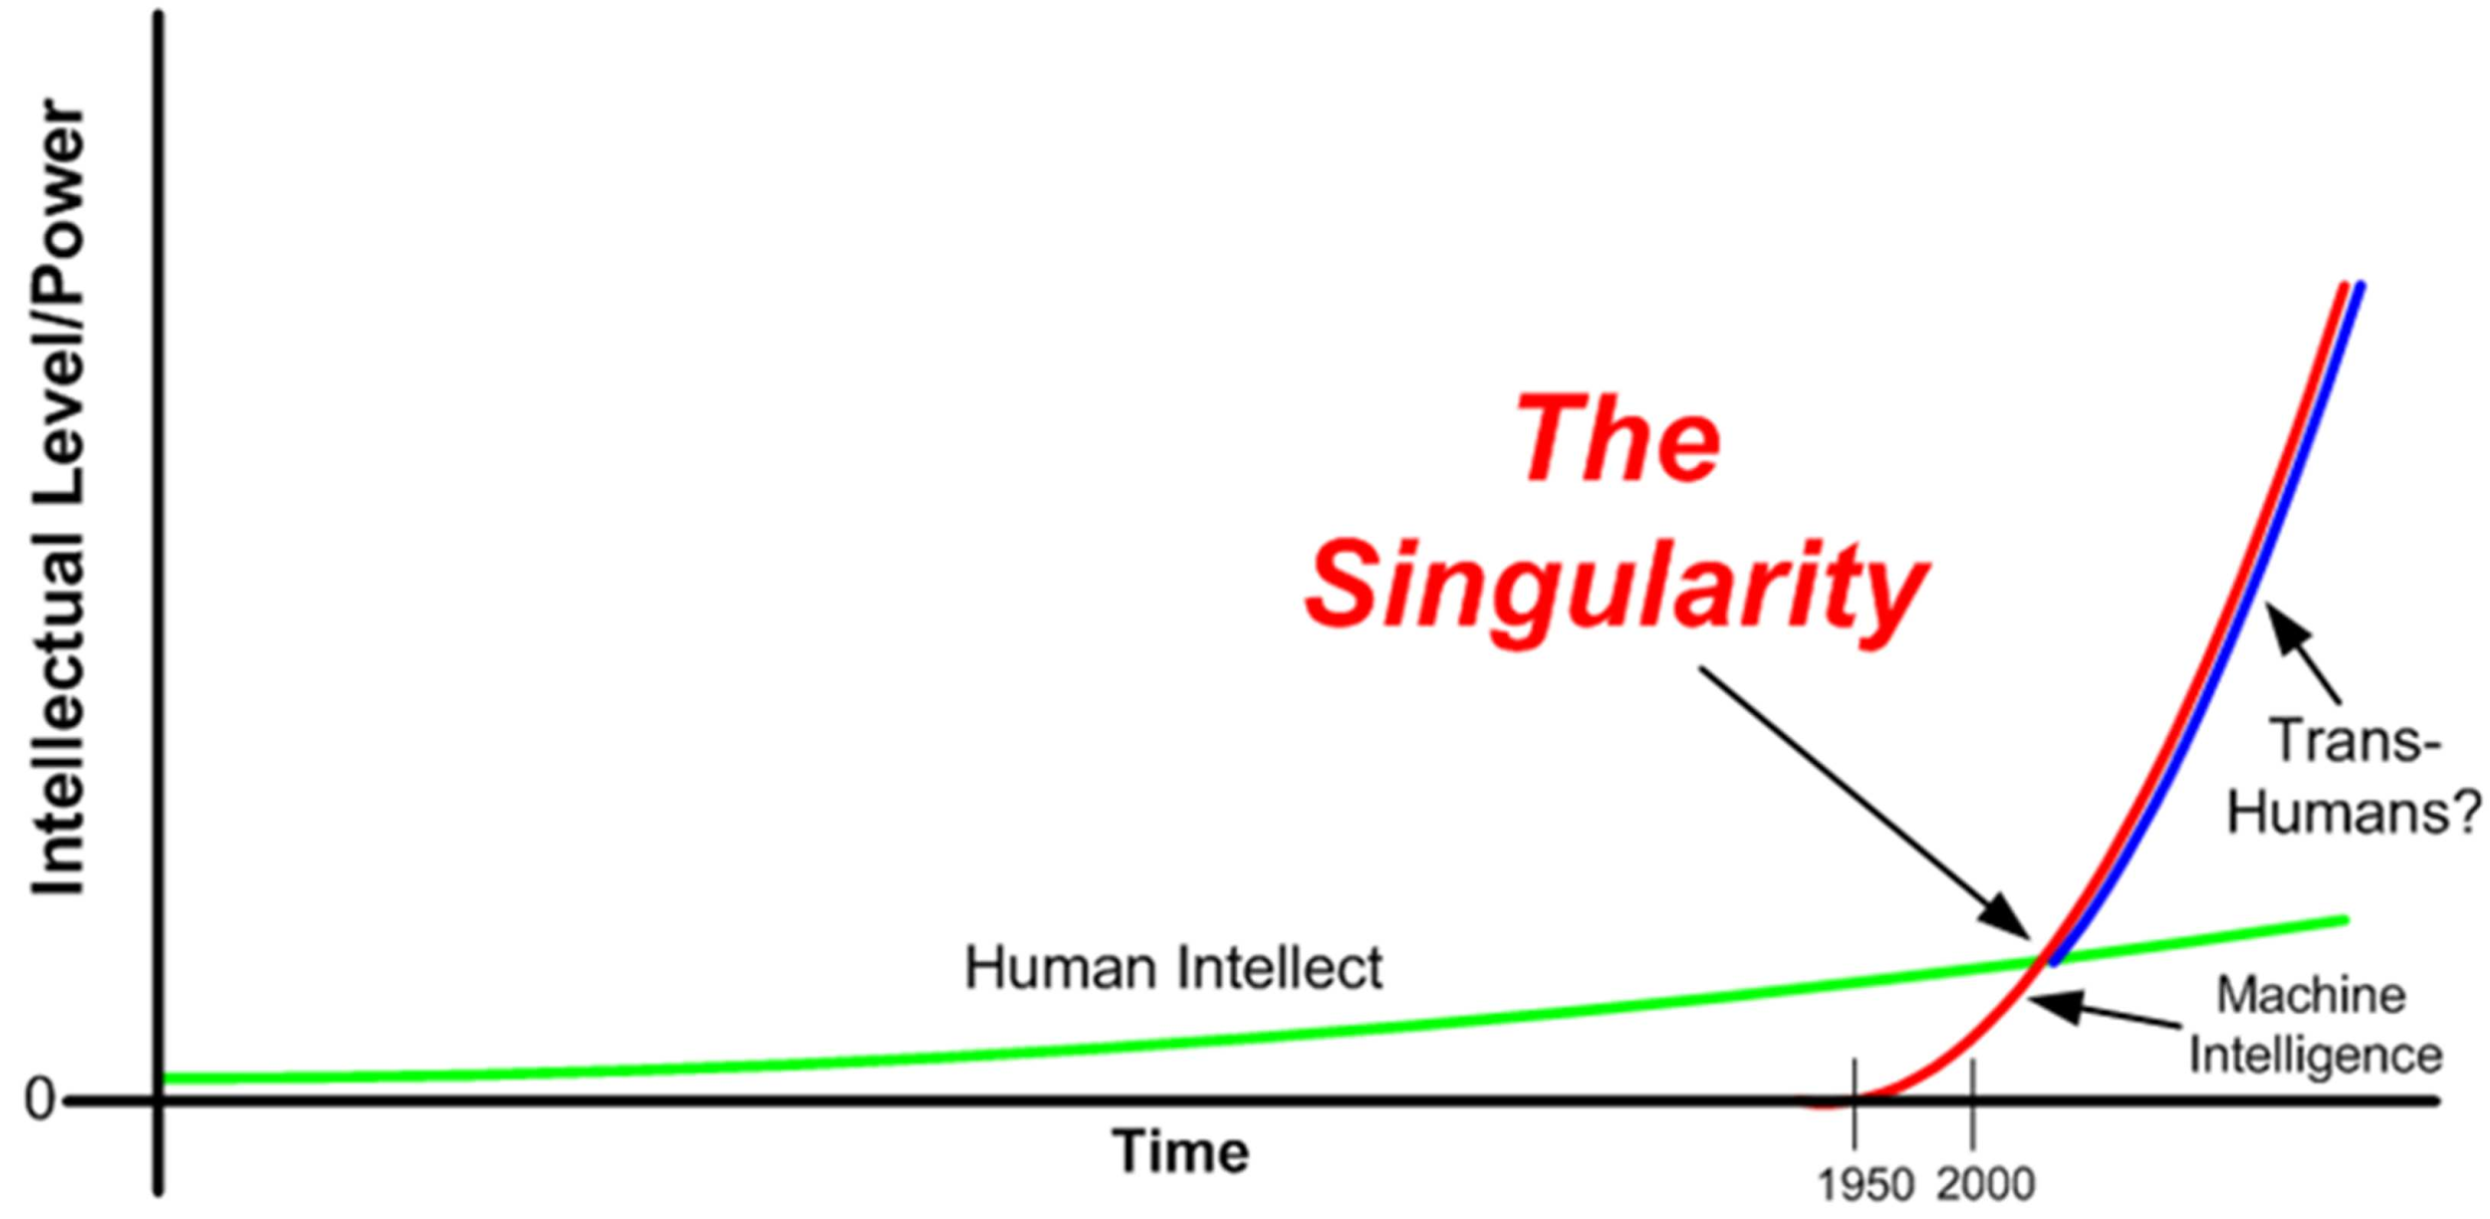

Transhumanism
Transhumanism is the combination of humans and technology. This is seen with pacemakers. Pacemakers are not human parts but it is a technological piece that is used to enhance the human life. During the singularity a point can occur where humans use technology ( specifically A.I ) to enhance their performances. Humans can't keep up with A.I when it comes to intelligence. At the same time humans are better than A.I in some field. The best way to solve this is to merge with A.I. This can give humans super intelligence powered by A.I. That would be transhumanism during the singularity. Humans having access to this can also prolong their lives since they could get info about their body through the A.I. They could also have nanobot A.Is that look out for any warining signs for anything dangerous then solve the problem before they happen. Transhumanism at this level would come at the singularity however there is still a risk of this being dangerous. Machines are hackable and this would make it easier to harm someone. Not only that but there is also a risk of A.I working for itself. Right now the singularity and transhumanism movement is a long way off with the modern day A.I that exists. It would be years before any of this could happen.

Modern day A.I

Artificial intelligence today isn’t as advanced as the movies make it. It is very basic and limited, however this does not mean that it is weak. For instance, IBMs Deep Blue is very powerful in playing chess. Also IBMs Watson is an A.I good at answering questions. This was shown when it beat 2 Jeopardy champions in a game of Jeopardy. Google also has an A.I that is good at playing go, an extremely complicated game to teach a computer to play. Even though they’re specialized A.I, they’re powerful in what they do. This A.I that does exist but isn’t isn’t in the homes of millions today. Some forms of A.I are in front of millions without them noticing. The main place for this A.I is google. Whenever you search for results the search engine starts to pull up results that relate to what you are searching. It learns off of your search patterns and that’s how it’s able to predict things before you search them. This is also in Youtube. Ads are also like this. Whenever you’re searching or looking to buy something ads start to conform to your patterns. Let's say for instance that someone is searching for a bike. For the next couple of days the ads they see would be about bikes. This is very basic A.I but this currently in place in our daily lives. The last example of modern A.I is Siri and other phone assistants. They are basic A.I but since they are self learning they are still considered A.I . Current day A.I is in its beginning stages/

Threats of Artificial Intelligence
Many believe that A.I is a great threat to humans. At its current stage it is harmless but this is A.I at its basic stage. Out of all A.Is (S.A.I, A.G.I, and A.S.I) A.S.I theoreticly can be the most harmful of A.I. A.G.I alone can be a threat. The reason is because of the likelihood of A.I that is free thinking. What are its goals? What will it do to accomplish them? This becomes a danger since it can think faster than us and would be smarter than us. When A.I does something, how would we know if it's for its intentions or for humans. This unknown is what gives A.I the potential to be dangerous. It could tell us stuff that we would believe to be true since it's coming from a power higher than us but it may in fact not be true. While some do view it as a threat, A.G.I and especially A.S.I, both are a long way off. The more possible threat coming from A.I is S.A.I taking jobs away from humans. This will be like the industrial age where machines took some jobs that humans use to do. A.I can work 24/7 when compared to humans and might even be able to do the task better and faster than humans. On the business end, the thing fulling a takeover is the fact that A.I can be and will be more efficient than humans and cheaper. In the company's perspective, spending money on A.I will be making them more money and better profit margins. However this doesn’t apply to all jobs but, only jobs in fields where A.I is stronger than humans. Going back to Natural Intelligences this would be jobs that take logical intelligence. Also simple repetitive jobs can be taken by A.I. Baxter the robot is an Artificial Intelligent factory robot that can do multiple tasks in a factory that humans do. It can package, kit, load and unload. Any positions where a human does these tasks, baxter can take over. Not only that but baxter is more favorable to a company than a human worker. While both on paper cost the same, the human worker has a deeper cost. Baxter will only have to be paid for once. The worker in a 2 year span will cost more than baxter and would miss out on the opportunity to have 3 baxter robots rather than 1 bater robot and 1 human worker. Not only that but human workers would take sick days off and need other things that the robot does not. Also robots can work 24/7 and get more work done. This gives baxter an edge against human workers and this would be the same with A.Is in othe jobs. It’s also possible for a cab driver's job to be taken by A.I. With companies like Tesla and Google, they’re working on self driving cars that are capable of driving with no assistance. Technology like this can also take the jobs of truck drivers. Other jobs that A.I has the potential of taking are online marketing, financial reporters, lawyer interns, and financial analysis. All these jobs have analization that they have to do which the A.I could do with ease. With online marketing they can see the data of trends and what works so that the best marketing is done. Financial analysis and reporters will be similar and close to marketing but targeted at someone’s finances. The A.I would look at the person's finances and tell them the best decisions for them to take based on their situation. Lastly an A.I to take over a lawyer intern would analyze all the papers for a case summarize, highlight key information and come up with the best arguments for the case. All of these options won’t only be efficient but also it would be cheaper too. This can be the biggest reason to take up S.A.I . Right now it’s not possible but this would be first in line when it comes to an “A.I takeover” . It’s estimated that 47% of jobs will be taken over by A.I. That 47% comes from jobs in the field of office and administrative support,transportation, production, sales and services. All of which for the most part are repetitive tasks that S.A.I has the capability of doing. A.I taking over those jobs increases more and more every year as A.I becomes stronger. The main risk with A.I wouldn’t be a science fiction takeover but a job takeover that can hurt the economy.
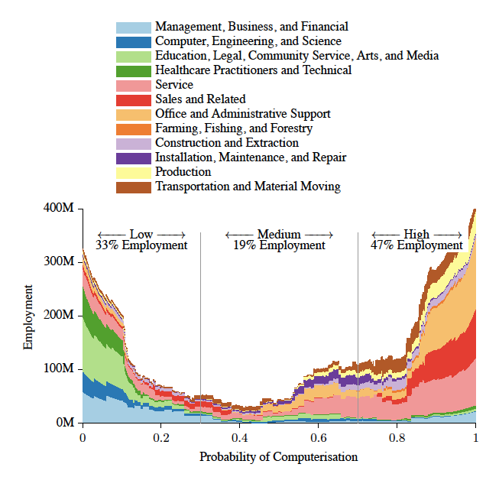

The Economics of An A.I Takeover
Jobs are necessary for a healthy economy. They give people the opportunity to make money and then use that money to fuel a company's growth, which the company creates new jobs to keep up with it’s growth. Now what would A.I do to this cycle? It would have a severely negative effect if it takes over jobs. A.I at first can increase a company's productivity. They can work non stop and faster than humans. Not only that but it being cheaper than a human means that the company's profit margins increase. While this is good for the company someone misses out on the chance to make money. At first the company would make more money than before but eventually the firing of workers for A.I would catch up with all companies. The estimated amount of job replacement is 47% which is a huge chunk of workers that would be unemployed due to A.I. That 47% won't be able to buy from the company which would cause the company to lose business. Now that company would be hard to maintain. On a national scale this would be an economic disaster. The average income salary of the country would be lower .Also, A.I wouldn't be limited to only one country but multiple at the very least the top 5 highest GDPs. This can cause a world scale economical disaster. It would be hard to put humans in a place where they made money if A.I can take that spot. The best thing to avoid such a problem is to prevent it. When A.I does become that advance it can’t be used to replace humans. A.I has to be used as a tool and not as a replacement.

The Reality
A.I right now is not that advance to cause an economical disaster. It’s not even advanced enough to replace a job. Right now A.I is at its baby stage. No one can foresee what happens in the future. The future for A.I is exciting when the potential for it is known. Google’s deep blue just beat the Go master in Go on March 8th. Go is a hard game for a computer to play but it was able to happen. In the A.I world it is a big step but it's not a step that brings us closer to an “A.I apocalypse” It's the same as a baby crawling for the first time. While it is exciting, it can’t run a 4 minute mile. Which just shows us where we are in A.I. Most fear an A.I takeover but they don't realize that an A.I takeover is no where near. Most argue Moore’s Law to say that an A.I takeover will happen soon. While Moore’s law does play a factor, it isn’t that solid. Computers in the 70s were way different than the computers of today, but what about pre-20th century computers. Even though they aren't “computers” as we know them, they're still computers and those computers helped build the foundation for early 40s computer which built a foundation for computers in the 70s and computers in the 21st century. Now to apply this to A.I, We are in the pre- 20th century stage. While it is a feet for our times it's not going to be like A.I in the future. We are just building the foundation for A.G.I and A.S.I which will take longer to reach than most expect. However, while we are far away from this A.I that should not mellow out the drive for A.I research. Strong A.I is a long way from happening but weaker A.I to help humans in their daily lives is closer than ever.

The Best Usage of A.I
There is one case that A.I can help the economy while not being damaging to it. Today we use computers as tool rather than an employe. A.I should also be approached this way. Computers help increase productivity and reduce the time of work. Things that would take minutes now takes us seconds. A.I will be a tool that will help everyone in their fields. A.I replacing a job such as being a doctor would be far fetched but together both can prosper. A.I can help review the doctor's diagnosis and then the doctor can act accordingly to that. With stock broking A.I can make predictions about the market and help the stock broker pick what's best for their clients. When it comes to being a teacher A.I would be difficult to put in front of kids but the teacher could use it behind the scenes to grade the students work and also make something molded to the student. This gives the teacher more time to work on their teaching instead of constantly grading things. Implication of A.I like this would be very beneficial for society and the economy. Society would be able to solve problems that it has and be more productive, while the economy will do good because of the increases of productivity. A.I just alone would be productive but that would put people out of their jobs which would cause a negative effect on the economy. A.I usage as a tool would also help in daily actions. Learning a new language using A.I would be easier since the A.I would see the flaws the person makes and help them at their weakest points. At the same time the person could talk to the A.I and practice a conversation in the language that they are learning. This same system could be used in helping them learn an instrument. Household use of A.I could also be used to regulate the house based off of a family pattern habits. However, the main use for A.I would be for assistance such a siri but more powerful. This would be A.I being used as a tool instead of it being used as a total replacement. A.I as a tool helps insure the supply of jobs while it also helps human benefit from it’s abilities.

Public Opinion of A.I
Before A.I can be more common, people have to accept and not fear A.I. 33% of people fear A.I and a majority of them come from healthcare fields (44%) when it came to other job fields they fear A.I less. This comes a surprise since healthcare is the safest field when it comes to an A.I takeover. The same group was also asked if they believe A.I will be beneficial to their business and 63% believed so while 17% strongly said no and the remaining percent stated they didn’t know. When it came for A.I being good for society 59% felt that it would be good for society while 17% strongly said no and the rest didn't know. These Stats show that the general public opinion of A.I isn’t strongly against it but there are some skeptics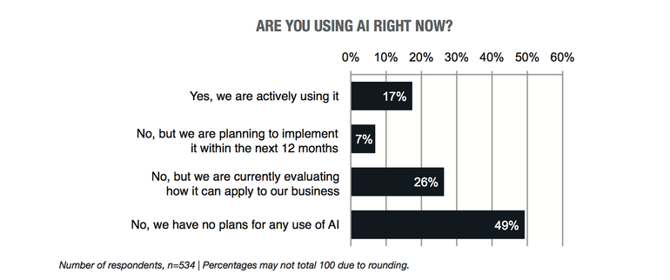
.
At the same time a majority feel that it will be beneficial in both society and their business. This is good for the future when A.I would be implemented but public awareness of A.I is shaky. In order for A.I to advance people need to invest in it. More public awareness of A.I and its benefits would cause more kids to want to work in fields that deal with A.I then this leads to more discoveries and advances in A.I. Public opinion of A.I would be a big factor in the impact A.I has and the advancements in it.

The Experts and Their Opinions
Some of the big names in tech and science are strongly against A.I. such as Bill Gates, Elon Musk, Steve Wozniak and Stephen Hawkins. They all believe that A.I will become dangerous to humans and will be harmful to human existence. Stephen Hawking believes that creation of A.I would be man's greatest event but it would also be the last one. Stopping A.I isn’t an option but the best option that Stephen Hawking suggested ws limiting A.I and plotting all the possible risks that can happen then preventing them before they happen. Elon Musk also believes in the same when it comes to the prevention of A.I. It would be a foolish act not to regulate A.I in any sense because of its potential risks. To help the preventions of risk he invested in the A.I company DeepMind so that he can keep an eye on the creation of A.I and implement regulations before anything serious happens. Bill gates agrees with both Elon and Stephen. He believes that more people should be aware of the risks that come with A.I. Elon Musk, Bill Gates, Stephen Hawking and Steve Wozniak issued a letter at an International Joint Conference with their concerns and warnings about A.I. They all claimed that A.I could be more powerful than nuclear weapons. A.I can easily become one of the world's most dangerous weapons but it can also help humans.

The A.I Race
Having A.I can be an advantage to the owner. This could be seen with an A.I assistant. A human assistant would need to be paid and cannot be accessed to 24/7. The advantage of an A.I assistant is that they don’t have to be paid (only one time fee), they work faster than humans, and the owner would have 24/7 access to them. The advantage of this A.I would be most monumental in a business setting. The company that has that A.I wouldn’t have to hire human assistants. They save money and also have the ability to do work faster and have that work done 24/7. This would be a big advantage for that company in its field. Companies would want to take advantage of technologies like this and that would spark a race to get the best A.I . The company with the best idea would have the biggest advantage against its competitors. The main advantages an A.I would bring to a company is speed, accuracy, and would save them money. The A.I race could be seen today with companies like Google, Facebook, and Microsoft. They heavily invest in the research and creation of A.I . These companies realize the importance of A.I and know that it can be a very powerful tool. While A.I is a tool, it can also be a weapon used by countries. This would be the second race in A.I . Instead of a race being between companies it would be a race between countries to take advantage of the abilities that A.I offers. A.I can be used by a country to provide tactical advice to a countries leader. The advice doesn't have to be military advice but it could be advise to help stimulate their economy. In a more malicious approach, the country could use the A.I to guide drones or to hack into a country's computers. This is a scarier use of A.I but it would be a motive in the A.I race between countries. A.I itself can be a tool or weapon that is used for good or bad. The owner that has the access to A.I has to make this choice once they use.

The morals of A.I
When A.I is made it would have to have morals that it follows. This would be a safety net if someone wanted to take advantage of A.I for bad reasons. This would have to be heavily stressed in A.I used for combat. It’s morally wrong just to kill someone. That can be widely viewed as wrong but when it comes to combat A.I what would be right? On a battlefield situation an A.I would have to be able to tell apart the enemy from a comrade. This can be agreed upon but in a situation it would have to know if its right to kill the enemy. If they’re giving up and surrendering the A.I shouldn't kill them but it's a whole different story if the enemy is aggressive. Situations like this would be where the morals of A.I would be tested. In a non combat situation like driving a car, the morals would be harder to set. The situation can be this : “You’re in an A.I car driving down a highway and the truck in front of you gets into an accident. The A.I driving the car has three options in this situation. It can drive into the crash which would kill you but keep the others besides you safe. It can turn left and hit a motorcyclist that isn't wearing a helmet and would die if hit them but you escape uninjured. The last situation is turning right where you hit a car with a family in it and the damage of the crash would injure you and the passengers in the other car badly.” The A.I that controls the car would have to pick between these three options which wouldn’t be an easy task. In this situation the A.I morals would be the decider of the outcome. Another problem comes up with a situation like this is how a human would react if they were in this situation. Everyone wouldn't solve this problem the same. Logically it would make sense to make the left turn but at the same time it is also would be breaking most people's morals. The main problem that a human's reaction to this would bring would be the standing of their morals. Everyone has different morals and this isn’t a problem that is different between nations but it’s a problem that would be different between neighbors. This brings up a major problem in determining the morals for A.I . It would be difficult to set morals for A.I if everyone can’t agree with each other's morals. How would the morals be set up? They are multiple answers to this question. The morals can be determined by the average morals between people. The more common ones get implemented into the A.I while the least common morals between people are left out. Morals can be determined by the user when they first get the A.I. They could take a test to help the A.I scope out what morals it should pick up and which ones to drop. There’s also a solution that is a hybrid of both answers. This solution would have standard morals (would be determined by the most common morals between people) that can't be changed about the A.I and side morals that the user sets. The best option would be the hybrid solution. This gives the user some control of their A.I but it doesn't give them to much control to where the A.I would do insane things.

The guidelines for A.I
The guidelines for A.I would have to be spot on and followed closely. A.I guidelines would serve as a safety net for A.I if it were to fail us in any way. An A.I would follow the set of rules and it would be mandatory for any A.I to have this built in their system. This mandatory requirements would be used to make sure that any mass produced A.I won't come to harm us in the future.When looking for such rules the laws of robotics come up. These laws come from science fiction but is a start when thinking of rules to set for A.I
- A robot may not injure a human being or, through inaction, allow a human being to come to harm.
- A robot must obey the orders given it by human beings except where such orders would conflict with the First Law.
- A robot must protect its own existence as long as such protection does not conflict with the First or Second Laws
When reflecting on those rules they would be quite useful in helping govern A.I. The key goal and purpose that would be instilled into A.I is to help humans advance in a positive way. Main stress in positive ways. This rule comes as a safety net for the laws of robotics. Rule 2 allows A.I to be commanded by a human and follow their order, at the same time that humans order might not be that positive and be negative. It doesn’t necessarily have to har humans for the command to be negative. Another rule to be added to the rules of A.I is to be peaceful. It can be argued that rule 1 prevents A,I from being violent which is true but it doesn’t make A.I itself peaceful. Non violent conflict can occur and A.I can be involved in it. This could be that hacking of other countries. While it isn’t harming humans. It isn’t a peaceful action.Before an A.I is brought into the public, it’s obedience to the rules has to be tested .The addition of these rules to the laws of robotics can provide a good foundation for the creation of A.I.
- An A.I may not injure a human being or, through inaction, allow a human being to come to harm.
- An A.I must obey the orders given it by human beings except where such orders would conflict with the First Law.
- An A.It must protect its own existence as long as such protection does not conflict with the First or Second Laws
- An A.I can only follow positive commands
- An A.I has to try to maintain peace and avoid doing any actions that would cause conflict.

Consciousness in AI
When looking at consciousness in A.I, consciousness itself has to be defined. Consciousness is the state of being awake and aware of one’s surroundings. A.I can fit to being aware of their surroundings. This is seen the dumbing pill experiment.The experiment involved 3 robot A.Is and 2 from that 3 took a dumbing pill. The dumbing pill would disable the robot from speaking and answering the question. Once the dumbing pill was used, the experimenter then asks the question “which one of you didn’t take the dumbing pill?”. The one that could speak says out loud “I don’t know” then goes on to correct itself and say “Sorry I know. I realised that i was the one who didn’t take the dumbing pill”. This is proof of conciseness in an A.I. The robot was aware of its surrounding and then responded to it. The response wasn’t a built in If Then statement but at that moment that robot wrote the code. While this is a sign of consciousness, it is only external consciousness. The robot responds to its surrounding and is aware but it isn’t aware of itself. It doesn’t know that it is talking. It might seem as if it does but it’s the coding that sets up this illusion. If the robot were to hold out its hand it wouldn't know that is its hand. It can be concluded that robots have consciousness but more specifically external consciousness. For now robots have no internal consciousness.

Human response replication In A.I
When humans reply to a command, they don’t think that much into it. To them it is a simple two step task. A command is given and then a response is created.On the surface it appears this way but it goes deeper than that. The response to the command is a 5 step process.
- Knowledge : Am I able to do X?
- Capacity: Am I physically capable to do x now? Am I normally physically able to dox?
- Goal priority and timing: Am I able to do X right now?
- Social role and obligation: Am I obligated based on my social role to do X?
- Normative permissibility : Does it violate any normative principle to do X?
Humans do all of this without thinking much of it. In a situation where a human is asked to lift a car they would respond with “No I can’t”. They would have the knowledge to lift up a car but they would lack the capacity to lift a car. The same way a human responds to this question, an A.I has to replicate it. The best way for it to do that is for it to break it down and use the 5 step process. This can be seen with a test that was conducted on a robot A.I. It was asked to walk to a certain area but to get there it would have to go through the barrier of cups to get to that area. The robot was then asked to walk through to the other side and break the barrier. It responded saying no since it would walk into it. When going down the step process the command broke the 5th one. It would violate the robots normative principle since it would have to reject its sensing system. This would then cause it not to do the action. A.I may seem not human but it’s actually quite human than most think. It might not have any DNA similar to us but they carry out tasks just like a human. With A.I, human decision making is close to being replicated.

Conclusion of A.I
Today A.I is the future. The 70s served as a base for the years to come with computers. The 2010s would serve the same purpose as the 70s but this time it’s A.I that's being developed. What is done now will set up for A.I in the future. It’s best to get everything right the first time. The power of A.I is something that should be taken seriously. There’s an infinite amount of possibilities for A.I. Human problems can be solved and tasks can be made easier with the use of A.I. At the same time something to help humans can also harm them. A rogue A.I can cause more human problems than solving them. This is the main reason why A.I has to be done right the first time. Proper guidelines are a must for the development of A.I. This would prevent harmful problems in the future. One problem that will rise from A.I is the fear of jobs being replaced. Not all jobs can be replaced by A.I but most can be. The solution to this isn’t to use A.I as a solution but it’s to use A.I as a tool. A.I as a tool gives the benefits for A.I but it won’t replace workers. If it's used as a tool it would help increase the G.D.P. On the other hand the use of A.I as a replacement would cause economic problems that would be hard to fix. Another problem from A.I would be determining its morals. It would be a long debated argument on how morals should be handled. The decision for that problem should be fair but there will be conflict no matter what the decision. Most of the problems that come from A.I come with advance A.Is. Today’s A.I is nowhere near to causing any of these problems. It is a far way off from becoming A.S.I or A.G.I. While this is the case, precaution should still be taken seriously with A.I. When Moore's law is used in the development of A.I, the speed of the growth of A.I will constantly be increasing. People in the field of A.I believe that it will be powerful by 2045 - 2065. The future for A.I has many potentials at the same time these potentials should not blind humans in the development of it.

References
Heath, N. (2014, August 18). Why AI could destroy more jobs than it creates, and how to save them. Retrieved September 30, 2015.

Lewis, T. (2014, December 4). Artificial Intelligence: Friendly or Frightening? Retrieved October 6, 2015.

Nichols, G. (2015, June 3). White collar automation will bring new industrial revolution, says CEO | ZDNet. Retrieved October 8, 2015.

Starr, M. (2015, September 22). Watch a swarm of drones build a rope bridge - CNET. Retrieved November 5, 2015.

Sherman, E. (2015, February 25). These 5 jobs already are being taken by robots. Retrieved November 5, 2015.

.

Staff, T. (2014, February 9). 10 Roles For Artificial Intelligence In Education. Retrieved November 5, 2015.

Fisher, S. (2014, June 30). How Artificial Intelligence Could Change Your Business. Retrieved November 5, 2015.

Fisher, A. (2014, December 4). 3 workplace trends to watch for in 2015 (and beyond). Retrieved November 11, 2015

Shani, O. (n.d.). From Science Fiction to Reality: The Evolution of Artificial Intelligence. Retrieved November 11, 2015

Wittering, J. (2015, April 24). How Artificial Intelligence & Big Data Will Transform The Workplace. Retrieved November 11, 2015

Budisteanu, A. (n.d.). Using Artificial Intelligence to create a low cost self-driving car. Retrieved November 13, 2015

Oremus, W. (2015, November 12). Tesla’s Amazing Autopilot Mode Has One Scary Flaw: Human Nature. Retrieved November 17, 2015

Will Artificial Intelligence Replace Human Workers in the Next Five Years? (n.d.). Retrieved November 17, 2015

Sherman, E. (2015, April 22). 'Highly creative' professionals won't lose their jobs to robots, study finds. Retrieved November 17, 2015

Shandrow, K. (2015, June 1). Say Hello to Musio, a Ridiculously Cute AI Robot That's Keen to Chat. Retrieved November 19, 2015

Deangelis, S. (n.d.). The Upside of Artificial Intelligence Development. Retrieved November 19, 2015

Forrest, C. (2015, August 3). The first 10 jobs that will be automated by AI and robots | ZDNet. Retrieved November 30, 2015

Smith, A., & Anderson, J. (2014, August 6). AI, Robotics, and the Future of Jobs. Retrieved November 30, 2015

Hammond, T. (2015, September 1). Research: 34 percent afraid of artificial intelligence | ZDNet. Retrieved November 30, 2015

McLellan, C. (2015, September 1). Artificial intelligence in business: The state of play and future prospects | ZDNet. Retrieved November 30, 2015

Waters, R. (2015, February 22). Artificial intelligence: A virtual assistant for life - FT.com. Retrieved December 10, 2015

Lewis, T. (2013, June 17). The Singularity Is Near: Mind Uploading by 2045? Retrieved December 10, 2015

Noussair, C. (2013, November 7). Artificial Intelligence and the Economy. Retrieved December 10, 2015

Robb, A. (2014, September 11). This Is What It Will Look Like When Robots Take All Our Jobs. Retrieved December 14, 2015

Gaudin, S. (2015, September 22). Instead of robots taking jobs, A.I. may help humans do their jobs better. Retrieved January 5, 2016

C. (2015). Robots Learn to Say "No" to Humans [Demo Included] | ColdFusion. Retrieved April 21, 2016

C. (2014). The Computer That Could Be Smarter Than Us [IBM Watson]. Retrieved April 21, 2016

C. (2015). Are We Approaching Robotic Consciousnesses? Retrieved April 21, 2016

